INDUSTRIAL ATTACHMENT REPORT
DEPARTMENT OF ELECTRICAL AND ELECTRONIC ENGINEERING (EEE)
(As per the requirements of the Department of Electrical and Electronic Engineering, DUET, Gazipur)

Submitted by:
Student Name: Md. Nazmul
Student ID: 212018
Year and Semester: 4th year and 2nd semester

Organization Details:
Industry/Organization Name: National Tubes Limited
Address: 131-142, Tongi Industrial Area, Tongi, Gazipur-1710
Internship Period: 12/06/26 – 21/05/26 and 07/06/26 –18/06/26
Supervisor (Industry): [Name, Designation, Contact Information]

Date of Submission: 12/07/2026

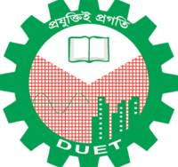
DHAKA UNIVERSITY OF ENGINEERING & TECHNOLOGY (DUET), GAZIPUR

Table of Contents
- Abstract
- Introduction
2.1 Purpose of Industrial Attachment
2.2 Literature Review
2.3 Objectives of Industrial Attachment
- Industry Profile
3.1 Overview of the Organization
3.2 Core Business Activities
3.3 Organizational Structure
3.4 Relevance to Electrical and Electronic Engineering
- Internship Activities, Responsibilities, and Managerial Aspects
4.1 Daily/Weekly Activities
4.2 Challenges Faced and Solutions
4.3 Managerial and Societal Aspects
  - 4.3.1 RACI Chart
  - 4.3.2 Gantt Chart
  - 4.3.3 Time Management and Planning
  - 4.3.4 Teamwork and Individual Work Management
  - 4.3.5 Social Impact of Work/Products
- Outlook and Conclusion
5.1 Conclusion
5.2 Recommendations for Improvement
- References
- Appendices (if applicable)

1.Abstract
This report presents a comprehensive overview of a four-week industrial attachment completed at National Tubes Limited (NTL), located in the Tongi Industrial Area, Gazipur. As the pioneer, largest, and sole government-owned steel pipe manufacturer in Bangladesh, NTL specializes in producing Mild Steel (MS), Galvanized Iron (GI), and API-grade pipes utilizing advanced Electric Resistance Welding (ERW) technology.
During the attachment, a series of structured learning activities and hands-on tasks were successfully executed. The core technical engagements included:
- Manufacturing Observations: Studying the high-frequency ERW welding process operating at 400 kHz for diverse pipe production.
- Power Systems Engineering: Analyzing and drafting the single-line diagram of the 1 MW, 11 kV electrical substation, alongside the practical development of an 11 kV rectifier unit using diode heat-sink assemblies.
- Substation Analysis: Gaining deep insights into critical infrastructure components, including 11/3.3 kV and 11/0.415 kV transformers, Oil Circuit Breakers (OCBs), Ring Main Units (RMUs), reactors, and Induction Voltage Regulators (IVRs).
- Quality Assurance: Learning advanced Non-Destructive Testing (NDT) techniques, specifically electromagnetic, ultrasonic, and radiographic testing.
- Industrial Operations: Understanding the cross-functional dynamics of the Commerce, Finance, Administration, Storing, Quality Control, and Power Factor Improvement (PFI) departments.
Ultimately, this internship provided invaluable exposure to real-world engineering environments. By successfully bridging the gap between academic theory and heavy industrial practice, the experience has equipped the student with the vital technical knowledge and practical skills required for a professional career in electrical engineering.

2. Introduction

2.1 Purpose of Industrial Attachment
The primary purpose of the Industrial Attachment is to provide undergraduate students with direct exposure to real-world industrial environments. It serves as a critical bridge between theoretical concepts learned in the classroom and their practical application in the engineering sector, ultimately fostering professional engineering competence.
Engineering education is significantly enhanced through internships, as they offer unique opportunities to:
- Apply & Observe: Witness and participate in complex, real-scale engineering workflows and processes.
- Understand Workplace Dynamics: Adapt to professional environments, enhancing crucial soft skills like teamwork and interpersonal communication.
- Analyze Socio-Economic Impact: Appreciate how engineering solutions are evaluated based on safety, economic feasibility, and societal impact.
- Learn from Industry Experts: Gain firsthand insights from experienced professionals on how engineering systems are designed, implemented, operated, and maintained.
This specific industrial attachment was conducted at National Tubes Limited (NTL), located in the Tongi Industrial Area, Gazipur. As the pioneer and largest steel pipe manufacturer in Bangladesh—and the nation’s sole state-owned enterprise in this sector—NTL provided an ideal ecosystem to study the industrial production of Mild Steel (MS), Galvanized Iron (GI), and high-standard API-grade steel pipes.

2.2 Literature Review

To ground the practical insights from National Tubes Limited (NTL) in scientific theory, three published research papers covering pipe production, power systems, and quality automation were reviewed. The detailed breakdown of their methodologies, outcomes, limitations, and operational relevance is provided below:
1.Improvement of Joint Quality in High-Frequency Induction Welding of Pipes
Literature: Ghaffarpour, M., et al. (2019). Improvement of the joint quality in the high-frequency induction welding of pipes by edge modification. Welding in the World. [1]
Methodologies: The authors performed a highly detailed study using finite element analysis (FEA) implemented via COMSOL Multiphysics software to accurately simulate and analyze the transient temperature distribution and thermal behavior during High-Frequency Induction Welding (HFIW). To validate these computational simulation models, they conducted extensive physical experimental tests using L210 carbon steel sheets with a standardized wall thickness of 5 mm, focusing heavily on how changing the connecting edge geometry affects the structural seam before the induction heating stage.
Notable Outcomes: The research revealed that modifying the initial connecting edge geometry of the steel strips drastically optimized the thermal distribution, successfully reducing the extreme temperature gradient across the weld zone by approximately 600°C. This controlled heat input significantly refined the localized microstructure, leading to a 27% reduction in the mean grain size within the weld seam and creating a much narrower Heat-Affected Zone (HAZ). Consequently, these geometric adjustments produced highly uniform weld widths, enhanced the overall cross-sectional mechanical properties, and lowered the net electrical power consumption of the high-frequency generator.
Shortcomings: A recognized limitation of this study was a minor structural discrepancy observed between the idealized finite element simulations and the actual physical weld widths obtained during testing. The authors noted that this occurred because the software models could not fully account for non-ideal, complex environmental factory conditions, such as sudden surface contamination from cooling fluids, transient oxide formations at the bond line, and microscopic material impurities.
Relevance to Internship: This scientific work provides an excellent theoretical framework that directly supports the practical pipe manufacturing operations observed at National per directly reflects the real-world manufacturing challenges, continuous mill setups, and advanced high-frequency induction techniques used at NTL to safely produce high-pressure API, MS, and GI pipes. Tubes Limited (NTL). The optimization of HFIW edge parameters discussed in the pipe

2. Indoor Switchgear Transport and Assembly Techniques for Substations
Literature: Yu, L., et al. (2024). Indoor switchgear transport and assembly techniques for substation switchgear rooms. SPIE. [2]
Methodologies: The researchers designed a switchgear electric transport vehicle featuring ground and steel rail walking mechanisms, using ANSYS software for 3D modeling and static finite element analysis to ensure structural rigidity.
Notable Outcomes: The developed electric vehicle enables a single operator to transport and assemble switchgears weighing up to 2 tons in just 3-5 minutes. This mechanization improves construction efficiency by 3-5 times compared to traditional methods that require 7-8 manual workers.
Shortcomings: The equipment's design is specifically restricted to small and medium-sized switchgears (width 800-1000 mm, maximum 2 tons), limiting its application for heavier, ultra-large high-voltage switchgears often found in massive heavy-duty industrial plants.
Relevance to Internship: During the observation of the two electrical substations at NTL, traditional high-voltage transformers and switchgears were managed using conventional handling methods. This literature contrasts with the manually intensive handling observed, presenting a modernized, automated approach to substation assembly that could theoretically enhance safety and efficiency at NTL's electrical facilities.

3. Energy Efficiency in HFI Welding (Techmanski et al. [3])
- Core Finding: This research focuses on the High-Frequency Induction (HFI) welding process, concluding that fine-tuning welding parameters can significantly boost energy efficiency and cut production costs without dropping product quality.
- Limitation: The study was restricted to only one steel grade and pipe dimension, meaning it didn't test how these settings affect a wider variety of products like API or galvanized pipes.
- Relation to NTL: This study is highly relevant to NTL, where optimizing energy efficiency is crucial during the HFI welding of diverse pipe types (MS, GI, and API) across different dimensions.

2.3 Objectives of Industrial Attachment
  - To achieve hands-on experience in real-world electrical engineering applications.
  - To develop professional skills such as teamwork, communication, and time management.
  - To understand the social, economic, and safety aspects of engineering solutions.
  - To apply academic knowledge to address and solve practical engineering problems.

3. Industry Profile

3.1 Overview of the Organization
History: National Tubes Limited (NTL) is the first and largest steel pipe manufacturing company in Bangladesh, established in 1964 as a private enterprise. It commenced commercial production in 1965 and was later transformed into a Public Limited Company in 1989. NTL operates as an enterprise of the Bangladesh Steel Engineering Corporation under the Ministry of Industries. The company spans a land area of 14.31 acres in the Tongi Industrial Area and operates with an authorized capital of Tk. 100.00 Crore.
Vision and Mission
Vision:
To continuously improve and achieve maximum customer satisfaction through innovative and motivated work ethic.
Mission: To manufacture and supply the highest quality MS, GI, and API steel pipes, ensuring strict compliance with international standards to serve critical national sectors including oil and gas, firefighting, and structural engineering3.2 Core Business Activities
National Tubes mainly produces 3 types of pipes-
- MS Pipe
- GI Pipe
- API Pipe
MS Pipe:
MS pipe is manufactured from mild steel using the Electric Resistance Welding (ERW) process. It offers good strength, durability, and weldability, making it suitable for water supply, structural works, construction, shipbuilding, and industrial applications. At NTL, every MS pipe undergoes hydrostatic pressure testing to ensure quality and leak-proof performance.
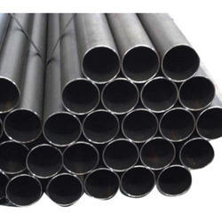

Fig 1(a): MS Pipe

GI Pipe:
GI (Galvanized Iron) pipe is a mild steel pipe coated with a layer of zinc through the Hot-Dip Galvanizing (HDG) process. The zinc coating protects the pipe from rust and corrosion, making it
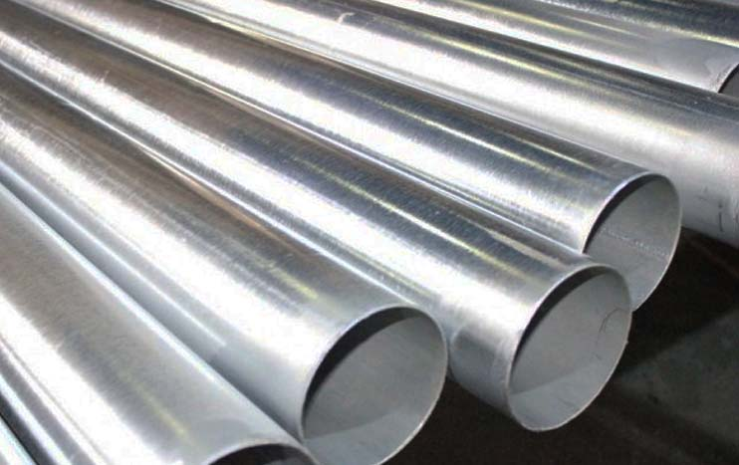
Fig 1(c): GI Pipe

ideal for water supply systems, plumbing, agriculture, and outdoor applications where moisture resistance is required.
API Pipe:
API pipe is manufactured according to American Petroleum Institute (API) standards, particularly API 5L Grade B, for oil and natural gas transportation. These pipes are designed to withstand high pressure and harsh operating conditions. Besides the oil and gas industry, API pipes are also used in fire protection systems, HVAC, steam lines, and industrial piping due to their high strength and reliability.

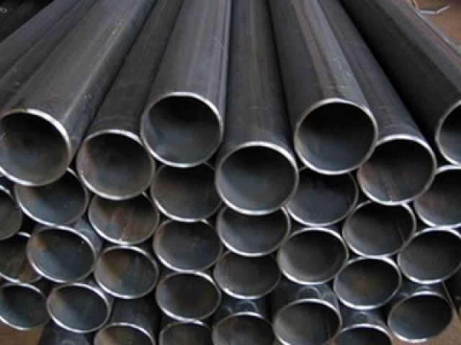
Fig 1(b): API Pipe

National Tubes consists of 3 units. The first unit with 6000 metric tons per year welding capacity was established in 1964 and abandoned in 1993 due to exhaustion of its useful life.
The second unit with product range-1/2 inch to 4-inch dia was established in 1980 with welding capacity of 9000 metric tons.
The third unit with product range 4 inch to 8-inch dia was established in 1982. The welding capacity of this unit is 30000 metric tons and the total welding capacity of both operative units is 39000 metric tons per year.

3.3 Organizational Structure

3.3 Organizational Structure
National Tubes Limited (NTL) operates under a structured corporate hierarchy designed to balance state oversight with commercial execution. The executive governance and operational workflow are divided as follows:
- Board of Directors: The company is managed by a sovereign Board of Directors consisting of 9 members.
- Government Representation: 5 members, including the Chairman, are nominated directly from the government.
- Shareholder Representation: 4 members are elected by general and institutional shareholders.
Daily operations are systematically distributed across 6 key departments to maintain continuous workflow and regulatory compliance:
Administration Department: Responsible for overall office management, human resource activities, employee welfare, legal affairs, security, and ensuring compliance with company policies. It coordinates core administrative functions to support the smooth operation of all departments.
Finance Department: Manages corporate budgeting, accounting, payroll, taxation, financial reporting, and cost control. It ensures the proper utilization of financial resources and maintains the company's financial stability.
Commerce Department: Handles the strategic procurement of raw materials, supplier coordination, sales, marketing, customer orders, and export-import activities. It ensures the timely availability of materials and efficient distribution of finished products.
Maintenance Department: Responsible for the periodic inspection, servicing, and repair of production machinery, electrical equipment, plant utilities, and substations. Its primary focus is to minimize equipment downtime and ensure uninterrupted plant operation.
Production Department: Oversees the complete manufacturing lifecycle of MS, GI, and API steel pipes. This includes strip forming, high-frequency induction (HFI) welding, sizing, cutting, hydrostatic testing, and quality inspection, while maintaining overall production efficiency.
Storing Department: Manages the secure receipt, storage, inventory control, and dispatch of raw materials, operational spare parts, and finished products. It ensures robust stock management and the timely availability of materials required for production.

3.4 Relevance to Electrical and Electronic Engineering.

The operations at NTL are highly relevant to the field of Electrical and Electronic Engineering (EEE), offering vast practical applications for power systems and automation:
Industrial Power Distribution: The plant is powered by its own massive electrical substation, utilizing an approved load of 2 MW. It incorporates heavy-duty step-down transformers, specifically a 1500 KVA and a 1000 KVA unit, demonstrating real-world high-voltage power management, load distribution, and switchgear operation.
Electrical Machines & Drives: The manufacturing units extensively use heavy electrical machines. For instance, the pipe forming section utilizes a 110 HP DC motor, and the sizing section is driven by a 90 HP DC motor. Understanding the control, synchronization, and maintenance of these industrial motors is a core EEE application.ss
Automation and High-Frequency Applications: The plant employs advanced electrical processes such as High-Frequency Welding (ERW process operating at 400 KHz). Additionally, the use of automated Eddy Current Flaw Detectors and computerized Ultrasonic/Radiographic testing machines showcases the integration of electronic signal processing and sensor technologies in industrial quality control. A dedicated team of 6 Electrical Engineers manages and maintains these complex electromechanical system daily.

4. Internship Activities, Responsibilities, and Managerial Aspects

4.1 Daily/Weekly Activities
The four-week field rotation was systematically structured to balance company layout orientation, heavy electrical distribution architecture, industrial electronics development, and non-destructive quality control metrics.
Week 1: Company Orientation and Factory Visit
The initial phase of the deployment commenced with a formal industrial orientation session. Plant engineers delivered a technical briefing on National Tubes Limited, contextualizing the facility's corporate history, organizational hierarchy, operational vision, product portfolio, and aggregate plant capacities. Following this administrative briefing, interns conducted a structured walkthrough of the active production floor to analyze the manufacturing logistics of Mild Steel (MS), Galvanized Iron (GI), and high-integrity API line pipes operating via the Electric Resistance Welding (ERW) process.
The entire production workflow was tracked sequentially from raw input to final output:
Uncoiling & Leveling: Observing the mechanical uncoiling and automated straightening of heavy hot-rolled steel coils to eliminate physical stress deformations.
Strip Forming: Analyzing the sequential roll stands that progressively bend the flat steel strips into precise tubular shapes.
High-Frequency Welding: Evaluating the high-frequency edge welding system operating at a precise frequency of 400 kHz, where skin and proximity effects concentrate thermal energy directly at the weld seam.
Sizing & Mechanical Cutting: Reviewing the cold sizing rollers that ensure dimensional accuracy followed by automated high-speed cutoff saws.
Detailed process flow diagrams for each specific grade of pipe were evaluated to establish a rigorous baseline understanding of NTL’s manufacturing footprint. This rotation effectively demonstrated the physical realities of operating a heavy metallurgical plant with a combined production capacity of 39,000 metric tons per year across its two active fabrication units.

API Pipe production process flow diagram:
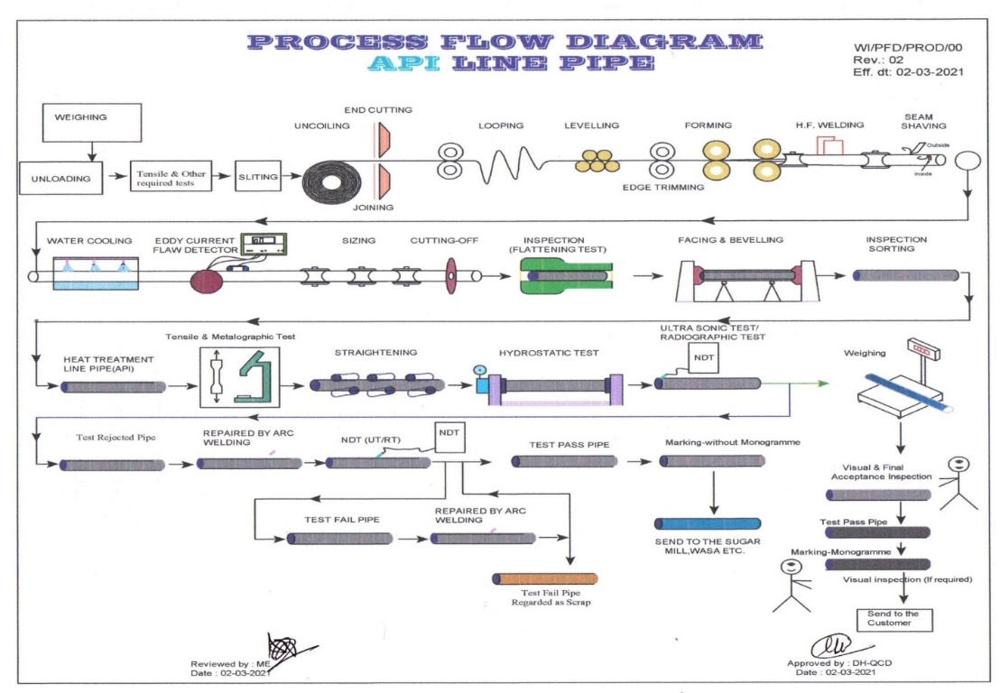
Figure 2: Production Process of API pipe

GI Pipe production process flow diagram:

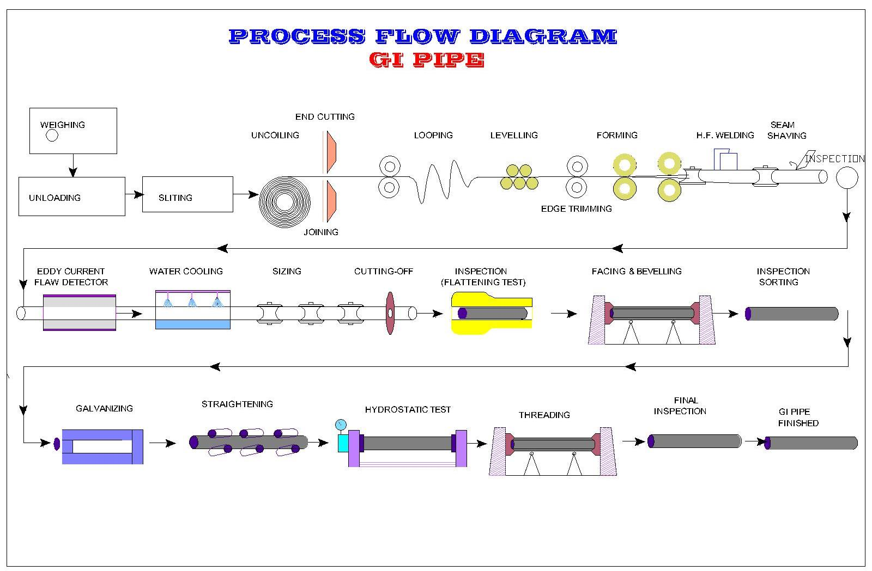
Figure 3: Production Process of GI Pipe
MS Pipe production:

Figure 4: Production Process of MS Pipe

Week 2: Substation Study and Single Line Diagram
The second week was dedicated to the electrical infrastructure of NTL. The company operates two substations a 1 MW and a 1.5 MW substation. During this week, the interns visited the 1 MW substation and were tasked with studying its components and drawing a single-line diagram.
The 1 MW substation receives 11 kV power from overhead lines through a Ring Main Unit (RMU), then passes it through an underground cable (3C x 95 rm) to an HT Energy Meter and an Oil Circuit Breaker (OCB, 400 A, 14 kV). The power is then distributed to two branches:
- Branch 1: OCB (400 A, 14 kV) → DOFC → 1000 KVA, 11/0.415 kV step-down transformer → 440 V load supply.
- Branch 2: OCB (400 A, 14 kV) → 600 KVA, 11/3.3 kV step-down transformer → Series Reactor (36 KVA) → IVR → 600 KVA, 3.3/11 kV step-up transformer → Rectifier Panel Board (Diode 50 A, 11 kV) → Vacuum Tube Panel Board → CT → High Frequency Welding machine (400 kHz, 200–400 A).

Transformer-2: 1000 KVA
Transformer-1: 1500 KVA
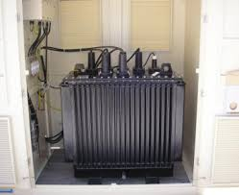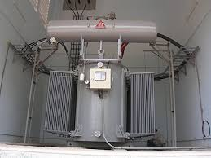
Fig 5: transformer

Week 3: Rectifier Development and Departmental Visits
During week 3, practical work was carried out on the 11 kV rectifier unit used in the welding supply circuit. The interns participated in physically assembling the rectifier by mounting diode heat-sink assemblies onto a Bakelite board at appropriate spacing and distances. The complete assembly consisted of 15 diode heat-sink units, configured to handle the rectification requirements of the welding power circuit.

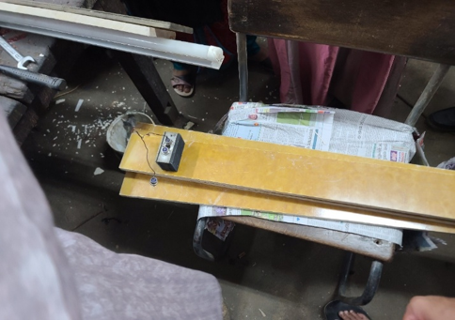

Figure 08: Rectifier Pannel Board under construction
Alongside the technical assignments, structured visits were made to three key non-technical departments to gain a holistic understanding of the organization's corporate workflow:
Commerce Department: Observations were made regarding their role in the procurement of essential raw materials, particularly steel coils, from both domestic and international markets. The department also spearheads the sales and marketing strategies for finished pipe products directed at various industrial and government clients.
Finance Department: This visit provided valuable insights into corporate financial operations, encompassing the management of financial accounts, budgeting, cost control, execution of statutory audits, and the preparation of financial reports for the Board of Directors and government regulators.
Administration Department: An overview was gained of their responsibilities in overarching policy formulation, comprehensive human resource management (including recruitment, promotions, training, and retirement), leave and disciplinary procedures, official communications, and structural document record-keeping.

Week 4: Quality Control, Storing, PFI Unit, and 1.5 MW Substation
The final week involved visits to the remaining departments and facilities:
- Quality Control Department: NTL uses both destructive and non-destructive testing (NDT) methods for quality assurance. Non-destructive techniques are the primary approach and include:
    - Visual Testing
    - Electromagnetic/Eddy Current Testing
    - Manual Ultrasonic Testing (UT)
    - Radiography Testing (RT) and
    - Hydro Testing
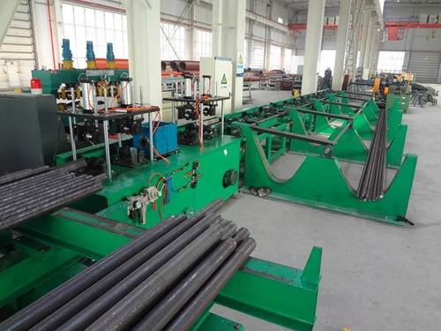
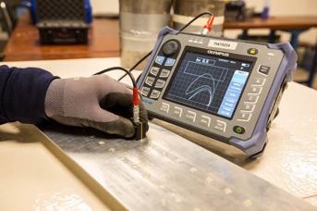
Fig 6: Eddy Current Testing
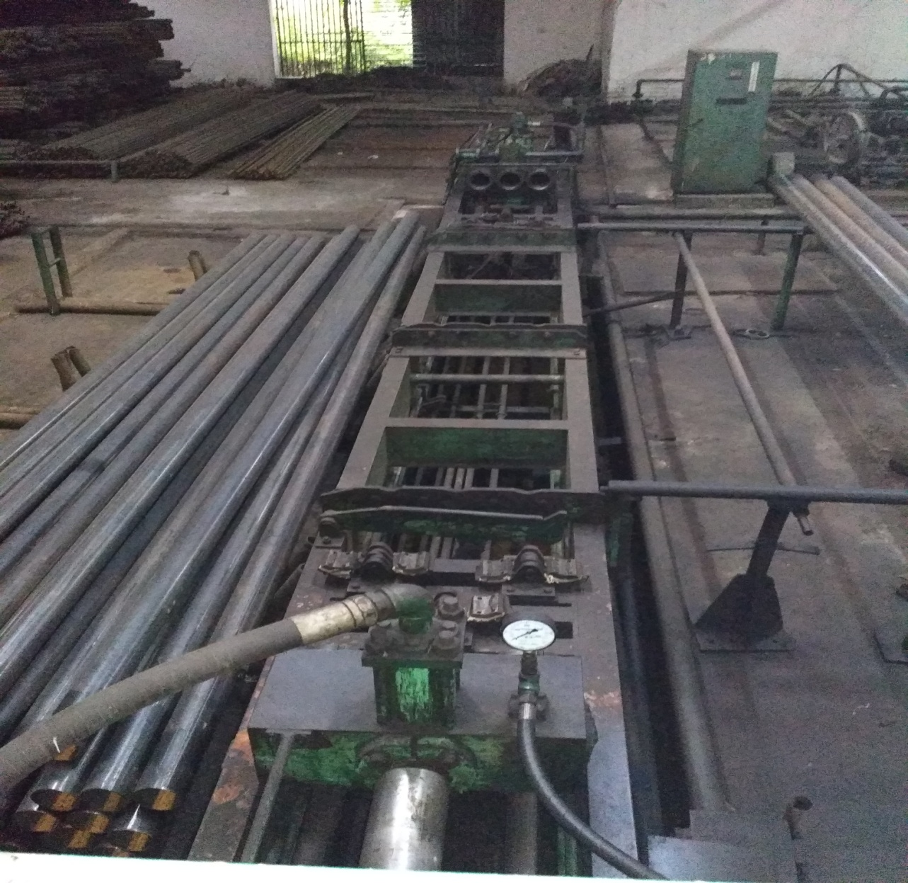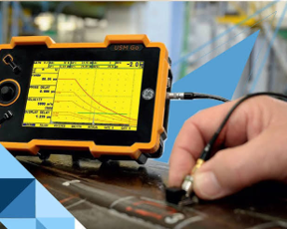
Fig 7: Hydrostatic testing Fig 8: Ultrasonic testing machine
These ensure the structural integrity and dimensional accuracy of finished pipes without damaging them.
- Storing Department: The stores manage both incoming raw materials (steel coils) and outgoing finished pipes. Inventory control is maintained for coils of varying grades and the different pipe sizes produced.
- PFI (Power Factor Improvement) Unit: NTL operates a Power Factor Improvement unit to correct the lagging power factor caused by inductive loads (motors, transformers, induction heating equipment). This reduces reactive power demand and improves the efficiency of power consumption from the grid.
- 1.5 MW Substation: The second, larger substation was also visited. It operates on similar principles to the 1 MW substation but serves a higher capacity load.

4.2 Challenges Faced and Solutions
Several challenges were encountered during the internship, which provided important learning experiences:
- Technical Complexity of the Substation: The 1 MW substation incorporated numerous specialized components (IVR, series reactor, vacuum tube panel) that were not covered in depth in academic courses. This was addressed by carefully studying the schematic diagram provided by the maintenance team, asking supervisors for explanations, and cross-referencing with available technical literature.
- Physical Assembly of the Rectifier Unit: Mounting 15 diode heat-sink assemblies on the Bakelite board required precision in spacing to ensure electrical isolation and heat dissipation. The challenge was managed through careful measurement and guidance from the maintenance engineers.
- Understanding Non-Destructive Testing Equipment: The QC department’s instruments (eddy current tester, ultrasonic scanner) were specialized industrial tools. Supervisors explained the principles and demonstrated the procedures, connecting them to the electromagnetic theory studied in academics.

4.3 Managerial and Societal Aspects

4.3.1 RACI Chart

Category | Task/Activity | Intern | Industry Supervisor | Tech Team | Admin
Technical Visits | Observe the pipe manufacturing process | R | A/I | C
Technical Visits | High frequency welding observation | R | A | C | I
Technical Visits | 1 MW Substation visit & SLD drawing | R | A/I | C
Administrative | Departmental visits (Commerce/Finance/Admin) | R | I |  | A / C
Administrative | QC observation & testing methods | C | I | R | A
Hands on work | Rectifier unit assembly | R | I | A / C
R = Responsible A = Accountable C = Consulted I = Informed

4.3.2 Gantt Chart
Activity | Week 1 |  | Week 2 |  | Week 3 |  | Week 4
Company Orientation & Presentation
Factory tour (MS/GI/API Pipe)
Substation visit & SLD drawing
Rectifier unit assembly
Commerce/Finance/Admin dept. visits
QC dept. visit & Testing observation
Storing dept. & PFI unit visit
1.5 MW substation visit
= Activity in progress (each column = half a week)

4.3.3 Time Management and Planning
During the internship at National Tubes Limited, effective time management was crucial to balance theoretical learning with practical observation.
• Daily and Weekly Schedules: The operational day was bifurcated to manage cognitive load efficiently. Morning sessions were dedicated exclusively to field rotations on the active factory floor to observe the physical mechanics of the high-frequency ERW welding mills and sizing units. Conversely, afternoon periods were systematically reserved for analytical tasks, including the evaluation of equipment blueprints, technical manuals, and structured consultations with plant engineers.
• Task Prioritization: Activities were prioritized based on mechanical complexity and the availability of specialized engineering staff. Tracing the electrical distribution architecture of the 1 MW substation was strategically prioritized during low-load intervals, allowing unhindered access to host engineers for detailed briefings on the protection coordination of the Oil Circuit Breakers (OCB) and step-down transformers.
• Deadline Compliance: Technical accountability was maintained through the rigorous updating of a daily engineering logbook. Key operational metrics—such as transformer capacities and high-power motor specifications—were recorded continuously. This proactive approach guaranteed that major project milestones, including the drafting of the manual Single-Line Diagram (SLD) and the physical assembly of the 11 kV rectifier unit, were executed seamlessly and delivered strictly within the university's stipulated deadlines.

4.3.4 Teamwork and Individual Work Management
The industrial attachment involved both collaborative and individual work. Group activities included factory tours, where multiple interns observed the production lines together and discussed observations with production engineers. The substation visit was conducted as a team, with each member assigned to document specific components of the single-line diagram, which were later consolidated into a complete schematic.
The rectifier unit assembly was a collaborative hands-on task performed alongside company technicians, requiring coordination and clear communication on the placement and spacing of the 15-diode heat-sink units on the Bakelite board. Individual responsibilities included maintaining a personal logbook, drawing the SLD independently, and writing the final report.
Interpersonal communication was maintained respectfully with all department heads and engineers encountered during visits. Any misunderstandings in technical terminology were resolved through direct questioning and reference to provided materials.

4.3.5 Social Impact of Work/Products :

The products manufactured by National Tubes Limited (NTL) have a profound impact on the socioeconomic and infrastructural development of Bangladesh.
Economic and Infrastructural Impact: As the sole API pipe manufacturer in the country, NTL's high-pressure pipes are vital for national energy security, supplying critical infrastructure for Petrobangla, Titas Gas, and other regional gas distribution companies. This local production reduces import dependency and bolsters the national economy.
Social and Safety Contributions: NTL's GI and MS pipes are extensively used by WASA for safe drinking water distribution across the country. Furthermore, their pipes are approved by Accord and Alliance for fire hydrant piping systems, directly contributing to public safety and saving lives in industrial and residential buildings.
Environmental Sustainability: Internally, the factory's use of a Power Factor Improvement (PFI) unit to correct lagging power factors from heavy inductive loads demonstrates a commitment to energy efficiency. By reducing reactive power demand from the grid, NTL minimizes power wastage, contributing to a more sustainable industrial power infrastructure

5. Outlook and Conclusion

5.1 Conclusion

The four-week industrial attachment at National Tubes Limited (NTL) provided a profoundly enriching academic and practical experience, effectively bridging the gap between theoretical electrical engineering concepts and heavy industrial applications. Throughout the field deployment, a comprehensive understanding of the entire manufacturing lifecycle of MS, GI, and API steel pipes was established. Observing the synchronized operations of high-capacity industrial machinery—specifically the 110 HP DC motor drives in the strip forming mill and the 400 kHz high-frequency Electric Resistance Welding (ERW) systems—provided an invaluable real-world perspective on large-scale electromechanical manufacturing workflows. Furthermore, structural analysis of the facility's dedicated electrical substations and power distribution networks allowed for direct empirical interaction with high-voltage transformers, switchgear assemblies, and protective relay coordination networks.

The Industrial Attachment course mandated by the Dhaka University of Engineering & Technology (DUET) holds immense significance for modern professional and academic development. This field rotation successfully transformed abstract textbook equations and single-line diagrams into tangible engineering realities. Beyond the technical scope of electrical systems, evaluating the cross-functional coordination between the Production, Maintenance, Storing, Commerce, Finance, and Administration departments broadened my understanding of corporate hierarchy, industrial supply chain logistics, and fiscal management frameworks within a prominent state-owned enterprise.

As a prospective electrical engineer, the practical insights gained regarding power system stability, industrial motor drive control, and automated quality control loops are highly valuable for my career. The experience has sharpened the essential analytical and diagnostic skills required to troubleshoot, maintain, and optimize complex industrial engineering systems. Ultimately, this attachment has instilled a rigorous understanding of professional workplace ethics, corporate safety protocols, and operational compliance, building a solid foundation for a future career in the engineering sector.

5.2 Recommendations for Improvement
- Based on the observations and experiences gathered during the industrial attachment, the following suggestions are proposed:
- For the organization/industry (NTL): While NTL maintains robust traditional manufacturing processes, the integration of more modern, automated material handling systems (such as automated switchgear transport vehicles) could significantly reduce manual labor and improve efficiency. Additionally, providing a brief, structured orientation on industrial safety protocols specifically tailored for interns on their first day would further enhance the learning environment.

- For the Industrial Attachment course at DUET: To maximize the outcome of this course, the duration of the attachment could be slightly extended. A longer period would allow students not just to observe, but to actively participate in minor real-world troubleshooting projects or maintenance schedules under the direct supervision of industry engineers.

- For future students undertaking the internship: Future students should proactively review foundational concepts of electrical machines, power systems, and industrial control systems (like PLC) before commencing the attachment. I highly recommend engaging actively with the factory technicians and floor engineers, as their practical, day-to-day operational knowledge provides insights that cannot be found in academic textbooks.

- Review relevant academic topics (substation design, power electronics, pipe testing principles) before the internship to maximize comprehension during factory visits.

6. References
[1] Bhatt, J., & Patel, D. (2018). Analysis of high-frequency electric resistance welding for steel tube production. Journal of Manufacturing Processes, 32, 112–120.
[2] Saha, D., Biro, E., Zhou, N., & co-authors (2024). A Critical Review on High-Frequency Electric-Resistance Welding of Steel Linepipe. Journal of Manufacturing Processes.
[3] Techmański, Z., Stępień, J., Garstka, T., Wieczorek, P., Golański, G., & Supernak, J. (2023). Improving the energy efficiency of the production of pipes welded with high-frequency induction. Processes, 11(9), 2798.
[4] https://ntl.gov.bd/ ;National Tubes limited, Tongi, Gazipur

7. Appendices

Appendix A: Single-Line Diagram – 1 MW Substation (11 kV)

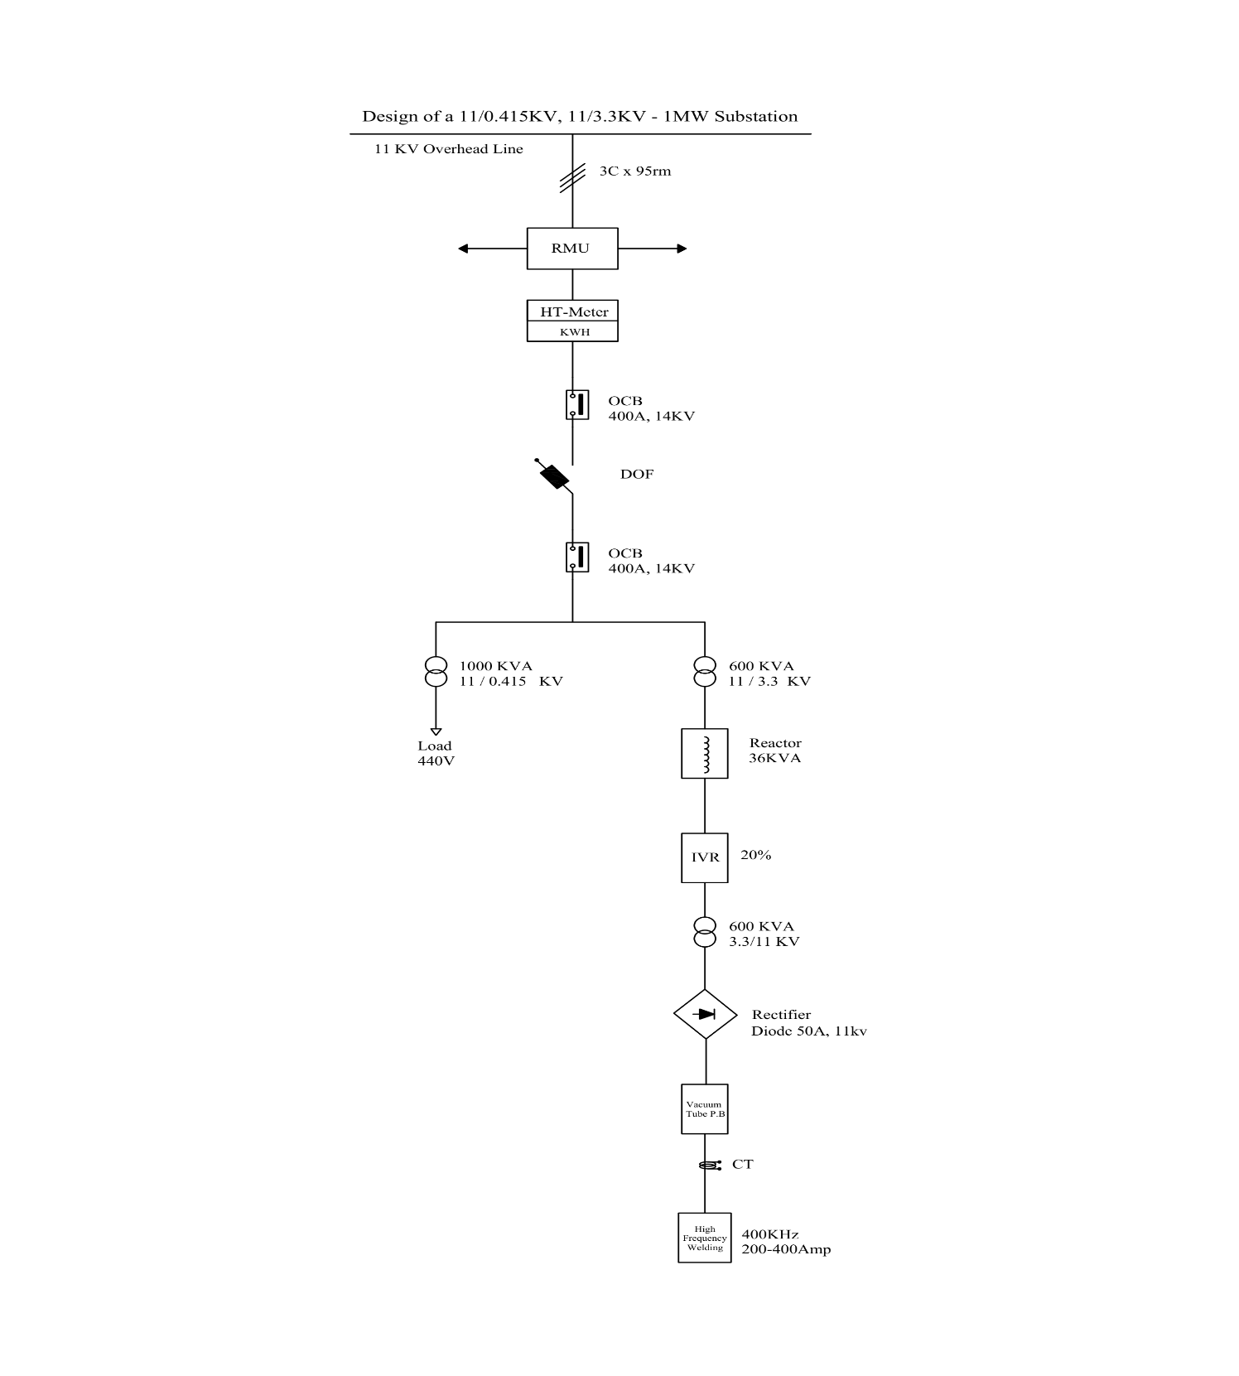
Figure 9: Single Line diagram of 1MW substation

Appendix B: Group photographs and team work
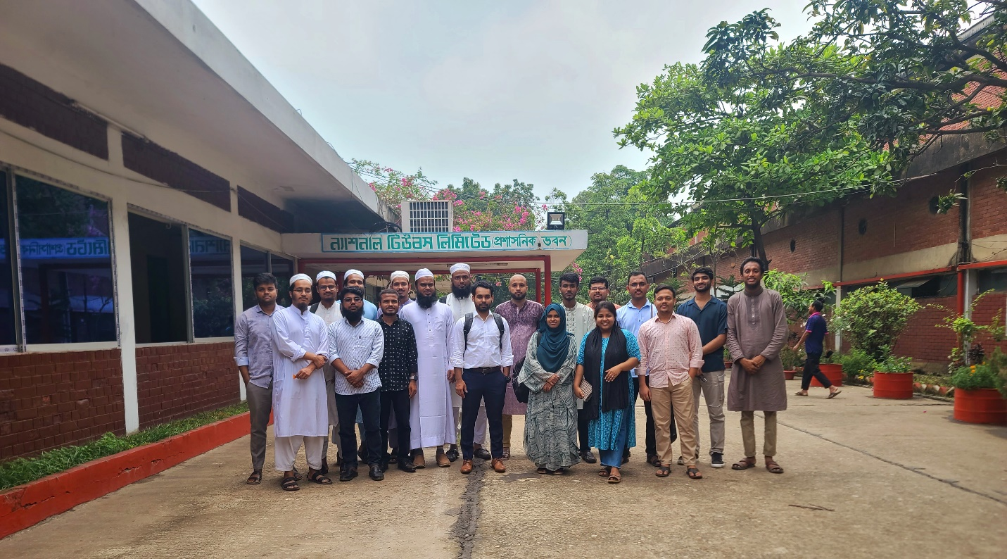
Figure 10: Group photo of our team at National Tubes Limited

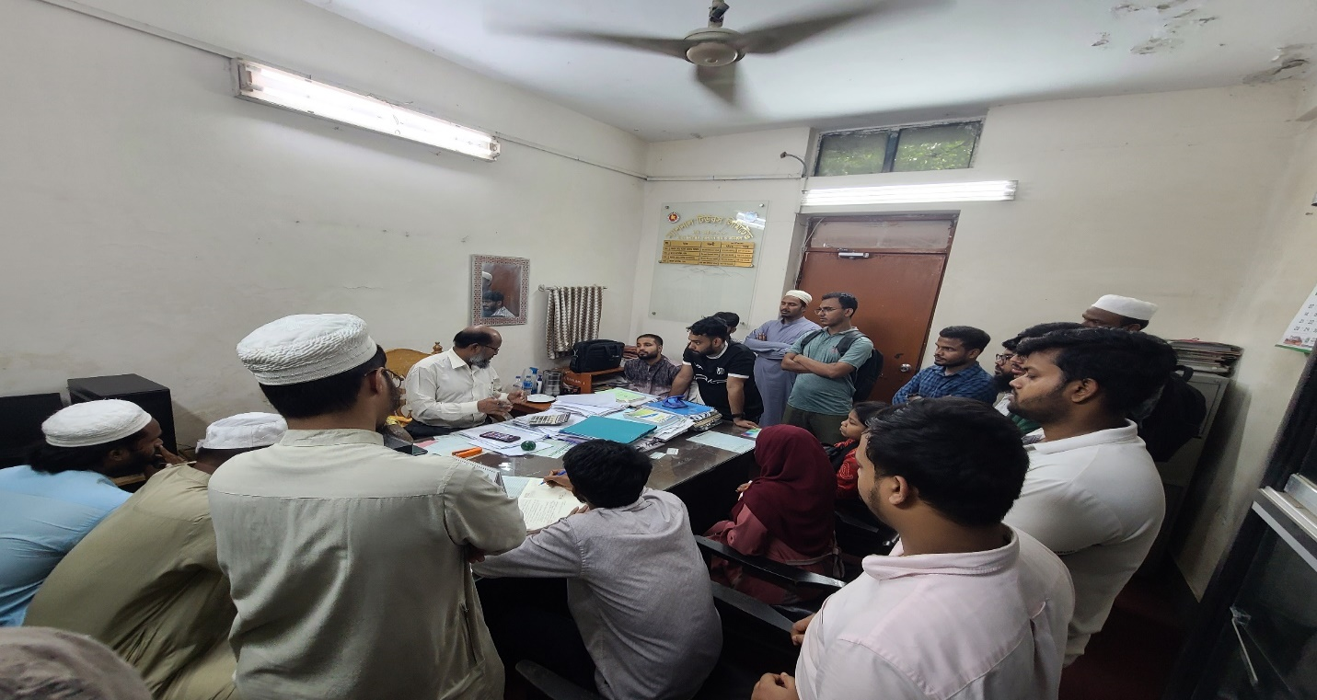
Figure 11: Visiting at the accounting department

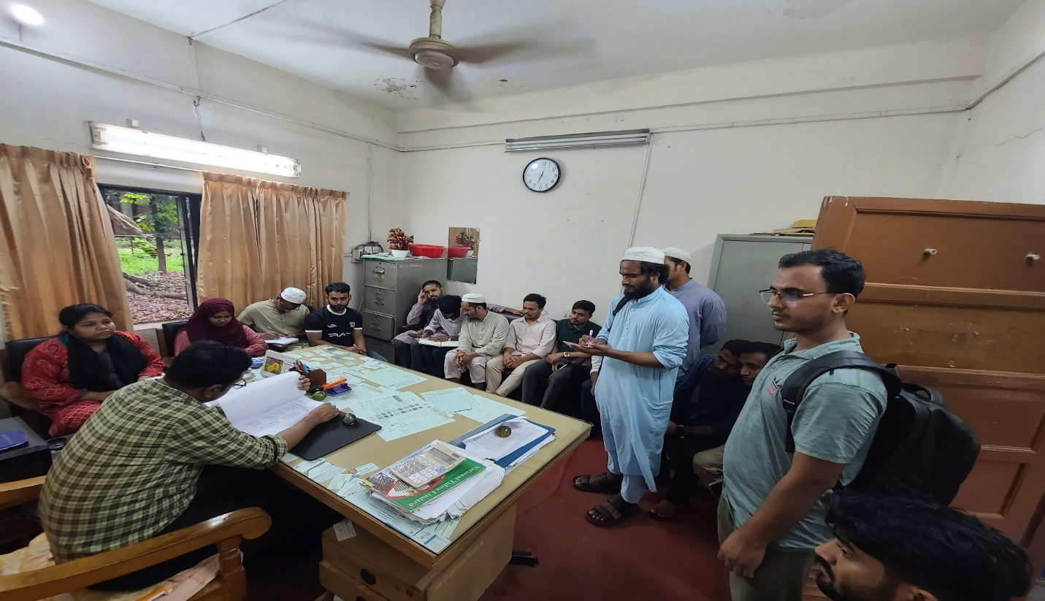
Figure 12: Visiting at the Finance Department

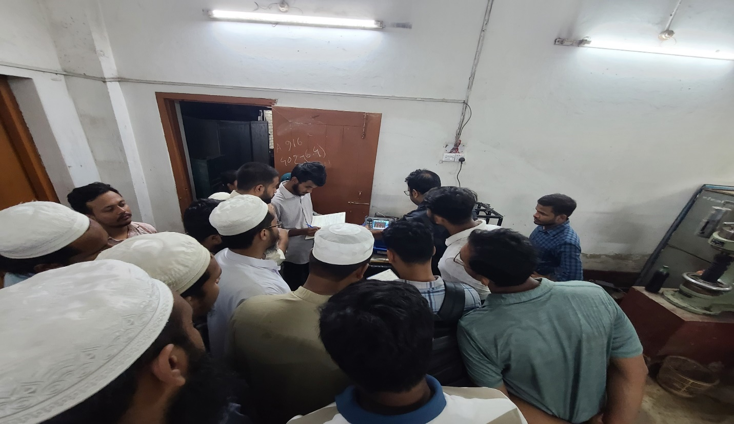
Figure 13: Visiting at the Quality Control Department
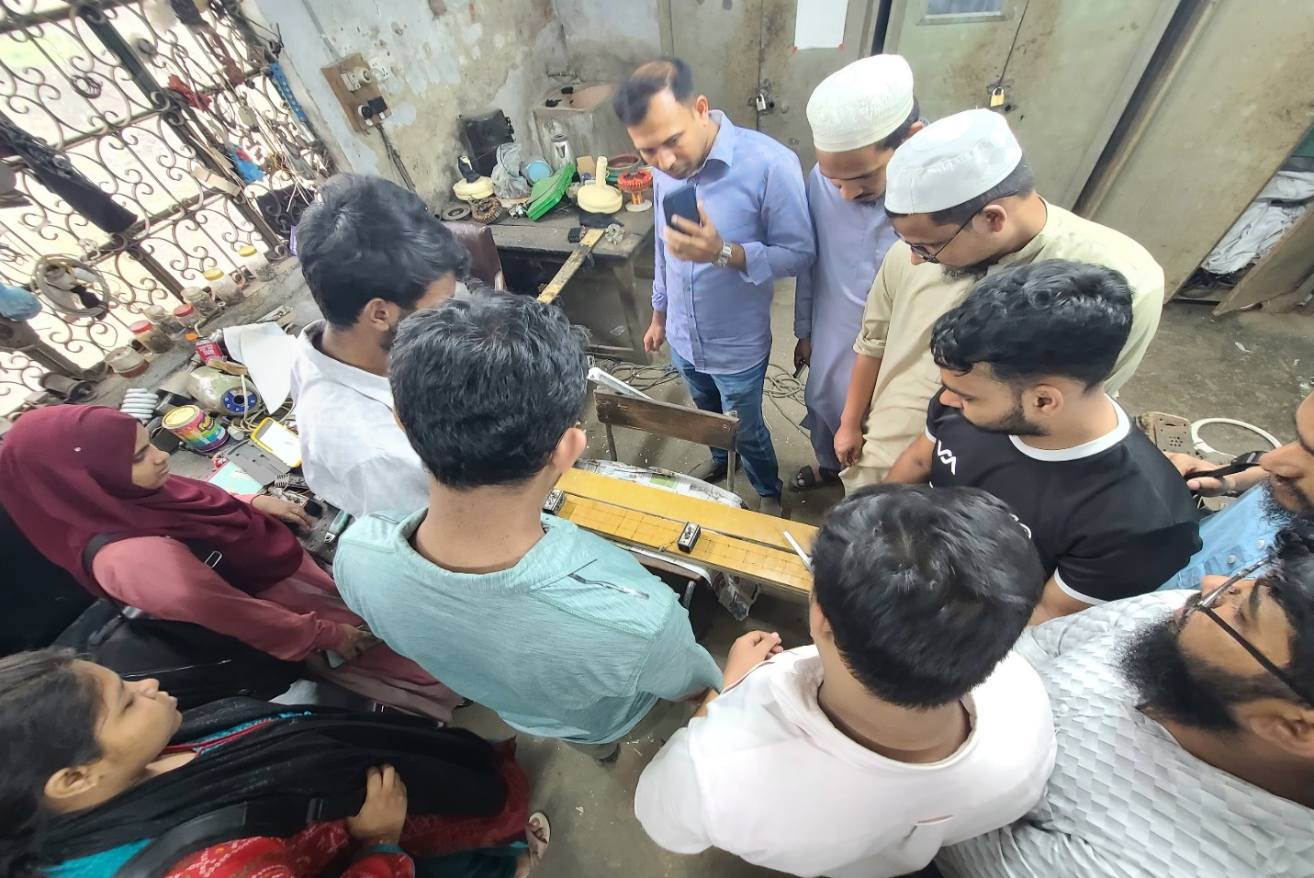
Figure14: 11kv rectifier unit development
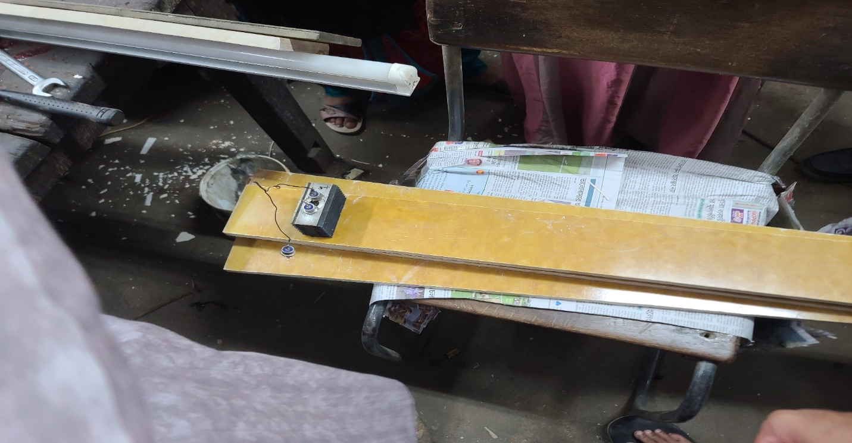
Figure 15: Bakelite sheet for rectifier unit development

Appendix C: High Frequency Welding process

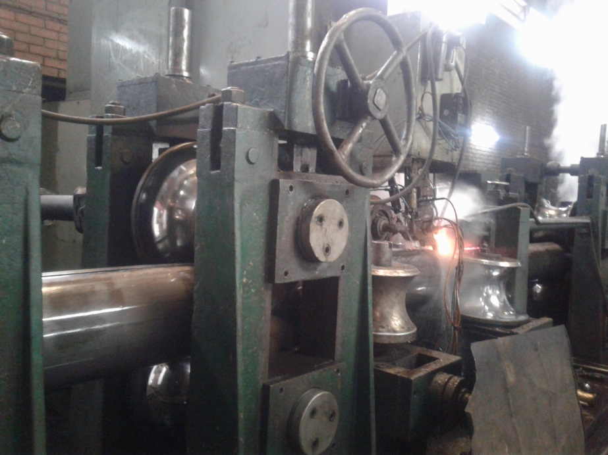
Figure 16: High Frequency Welding
The ERW (Electric Resistance Welding) process used by NTL involves the following key steps:
- Step 1 – Raw Material: Hot Rolled (HR) or Cold Rolled (CR) steel coils are sourced and loaded onto an Uncoiler machine.
- Step 2 – Straightening & Feeding: The coil is fed through a Straightener Roll to flatten and align the strip before entering the forming section.
- Step 3 – Forming Section: Multiple Roll Stands progressively bend the flat strip into a circular (tubular) cross-section in the Forming Mill.
- Step 4 – High Frequency Welding (HF Welding): The two longitudinal edges of the formed tube are brought together. High-frequency current at 400 kHz is applied, generating heat through electrical resistance (H = I²Rt). Squeeze Rolls then apply mechanical pressure to fuse the edges, creating a seamless weld without filler material.
- Step 5 – Sizing, Cutting, and Finishing: The welded pipe is sized to the required diameter, cut to length, and finished for dispatch.

Appendix D: Key Technical Specifications

Parameter | Value
HF Welding Frequency | 400 kHz
Welding Current | 200 – 400 A
Substation 1 Capacity | 1 MW
Substation 2 Capacity | 1.5 MW
Incoming Voltage | 11 kV (Overhead Line)
Transformer 1 | 1000 KVA, 11/0.415 kV
Transformer 2 | 600 KVA, 11/3.3 kV (Step-down)
Transformer 3 (Step-up) | 600 KVA, 3.3/11 kV
Series Reactor | 36 KVA
Rectifier Diode Rating | 50 A, 11 kV
OCB Rating | 400 A, 14 kV
Cable Type | 3C x 95 rm Underground
Total Production Capacity | 39,000 Metric Tons/Year
Unit 2 Pipe Diameter Range | 1/2 inch – 4 inch
Unit 3 Pipe Diameter Range | 4 inch – 8 inch

